*Problem Description*

*"""1. Create a student application using tkinter, PyQt5, or Kivy. Following functionalities should be  
present in the application. You need to create your Dabase file using SQLite.  
i. The application should accept First Name, Last Name, Street, City, State, Email,  
Telephone to insert this record in the database.  
ii. It should also list all the students in the database.  
iii. Delete a student  
  
Queries:  
‐‐Display list of students  
select FirstName+' '+LastName+'('+ cast(StudentId as varchar)+')' from Students  
‐‐Insert student record  
insert into Students (FirstName,LastName,Street,City,State,Email,Telephone)  
values('','','','','','','')  
‐‐Delete student record  
delete from Students where StudentId=0"""*

Step 1: Load Work from the database

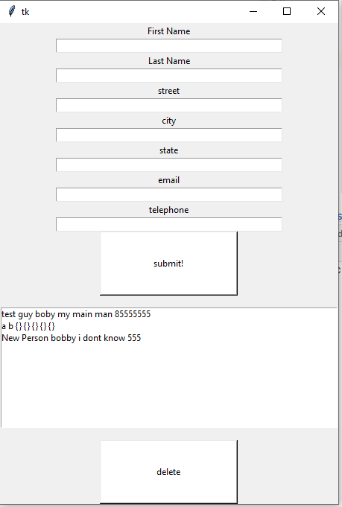

Item 2: Insert new person

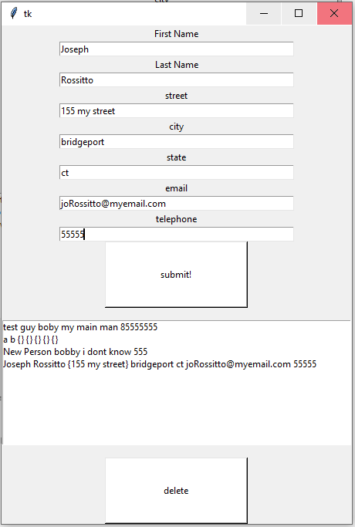

Item 3: Show List of students

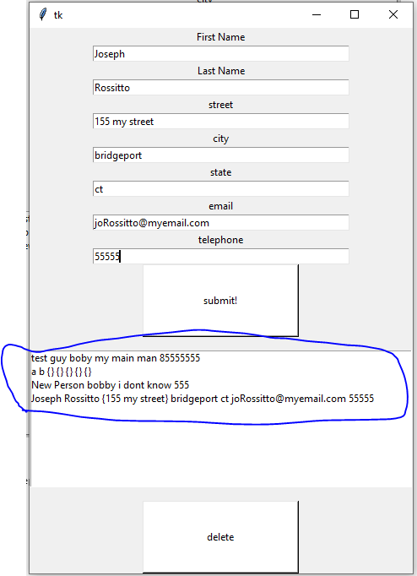

Item 4: Delete Old Student: Step one highlight old student

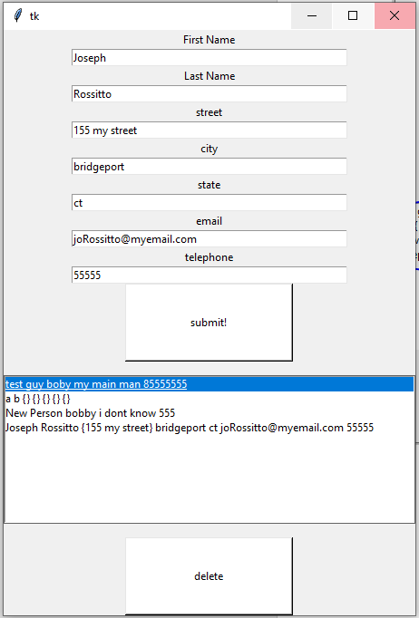

Item 4, Step 2: press the delete button and its gone

